Textile Center Supply List

Marilla’s Basket
Debbie Johnson

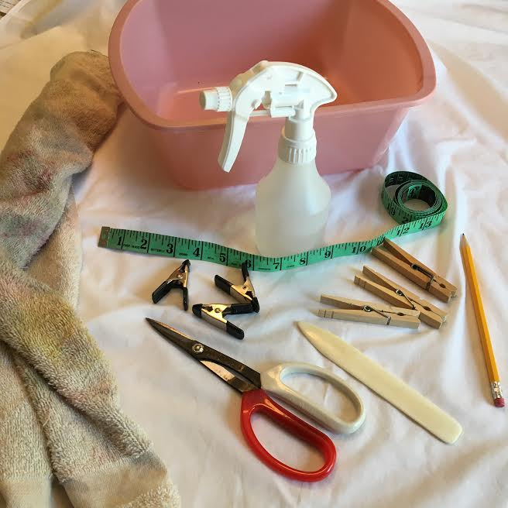
Please bring with you to class:
Materials fee $15, payable to the instructor (includes materials needed to create a basket, along with a bonus kit for a second basket)
Basin for water (size of dishpan)
Old towel
Scissors (not your good ones!) or garden shears
Pencil
Tape measure
Small spray bottle
Close pins
Awl or sewing point turner
12 clothespins or spring clips

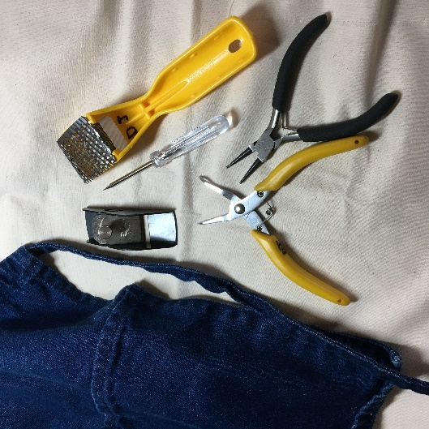
Optional:
Work apron
Needle nose pliers or similar
Small planer or rasp

There will be time reserved at the end of class for clean-up. Please help this process go quickly by assisting the instructor.

Parking is available in the lot directly behind our building, as well as our newly purchased lot at 3018 University Ave SE. Look for the green signs! Ring the bell at the back of the building for entry.

